CS 255 System Design Document Template

This template lays out all the different sections that you need to complete for Project Two. Each section has guidance to prompt your thinking. You will need to continually reference the interview transcript as you work to make sure that you are addressing your client’s needs. There is no required length for the final document. Instead the goal is to complete each section based on what your client’s needs are. Remove this note when you are finished, and replace all bracketed text with the relevant information.

UML Diagrams

UML Use Case Diagram
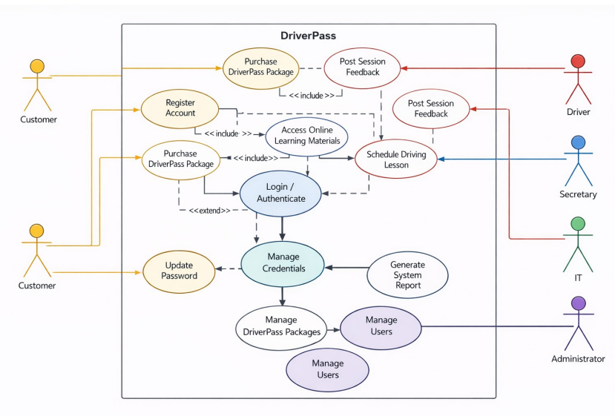

UML Activity Diagrams
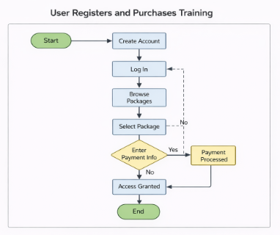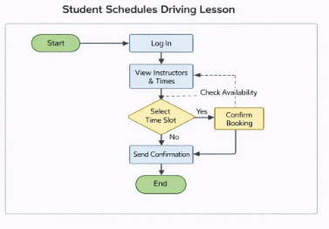

UML Sequence Diagram
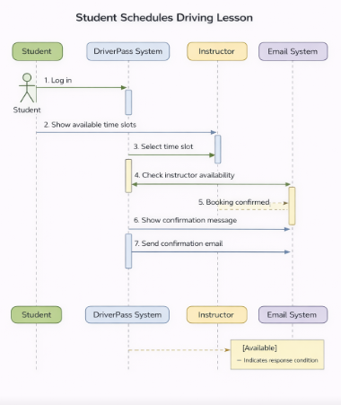

UML Class Diagram
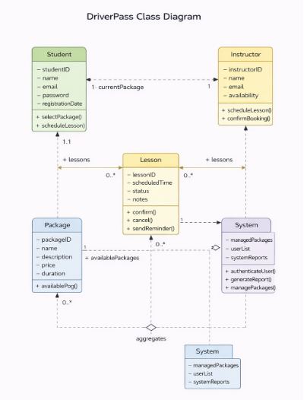

Technical Requirements
The DriverPass system requires a combination of modern hardware, software, development tools, and scalable infrastructure to support user registration, training purchases, and driving lesson scheduling. Based on the activity, sequence, and class diagrams, the system must support real-time user interaction, secure data handling, and reliable scheduling functionality.
From a hardware perspective, the system primarily operates as a cloud-based web platform, meaning most processing occurs on remote servers rather than user devices. End users such as students, instructors, and administrators only need basic hardware capable of accessing the internet, including smartphones, tablets, or desktop computers. However, the backend infrastructure must rely on high availability cloud servers capable of handling concurrent users, payment transactions, and scheduling operations. Redundant servers and load balancing may be required to ensure uptime and prevent service interruptions during peak usage.
The software requirements include both frontend and backend technologies. On the frontend, the system should use a responsive web interface built with modern frameworks such as React, Angular, or Vue to ensure compatibility across devices. This interface must allow users to create accounts, log in securely, browse training packages, and schedule lessons. On the backend, a server side framework such as Node.js, Java Spring Boot, or ASP.NET Core would be appropriate to handle authentication, scheduling logic, and business workflows. The backend must also integrate with a relational database system such as MySQL or PostgreSQL to store user accounts, lesson schedules, instructor availability, and package data. Additionally, a secure payment gateway integration such as Stripe or PayPal is required to support package purchases.
Development tools are essential for building and maintaining the DriverPass system. Version control systems such as Git and platforms like GitHub or GitLab should be used to manage source code and collaboration. Unified Modeling Language modeling tools such as Lucidchart, Draw.io, or Visual Paradigm are useful for maintaining system documentation and ensuring alignment between design and implementation. Integrated development environments such as Visual Studio Code or IntelliJ IDEA would support efficient development and debugging. Automated testing tools should also be included to ensure reliability, particularly for scheduling logic and authentication features.
From an infrastructure standpoint, the system should be hosted on a cloud platform such as Amazon Web Services, Microsoft Azure, or Google Cloud Platform. Cloud hosting enables scalability, allowing the system to handle increased demand as the user base grows. The infrastructure should include secure Hypertext Transfer Protocol Secure communication, firewall protection, and identity management systems to safeguard sensitive user data. A content delivery network may also be used to improve performance for geographically distributed users. Email services such as SendGrid or Amazon Web Services Simple Email Service are necessary to support automated notifications and booking confirmations.
Security is a critical technical requirement across all components of the system. The platform must implement encrypted data transmission using Secure Sockets Layer and Transport Layer Security, secure password hashing, and role based access control to differentiate permissions between students, instructors, and administrators. Regular backups and monitoring tools should also be implemented to ensure data integrity and system reliability.
Overall, the DriverPass system requires a scalable, cloud based architecture supported by modern web technologies, secure infrastructure, and reliable development tools. By combining responsive frontend interfaces, robust backend services, and secure cloud hosting, the system can effectively support its core functions of user registration, training purchases, and lesson scheduling while meeting the needs of both customers and business stakeholders.

